**CREATING A GITHUB LINK**

**Step1:-** Go to google and type Github as shown below

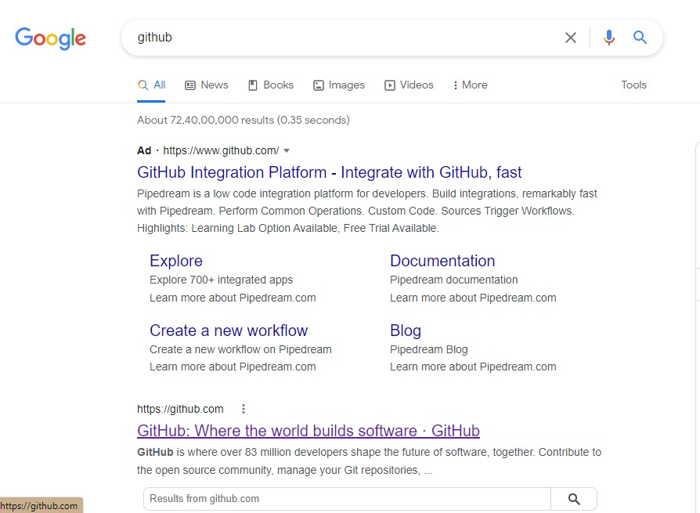

**Step2:-**

* now enter your email address.
* Create password
* And create username
* Click on continue

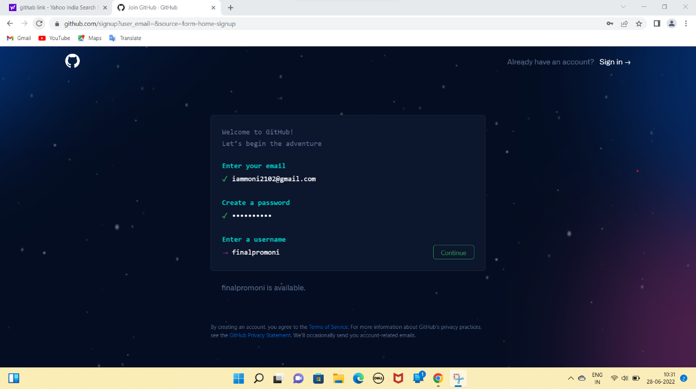

**Step3:-** now verify that you are a human and click on continue

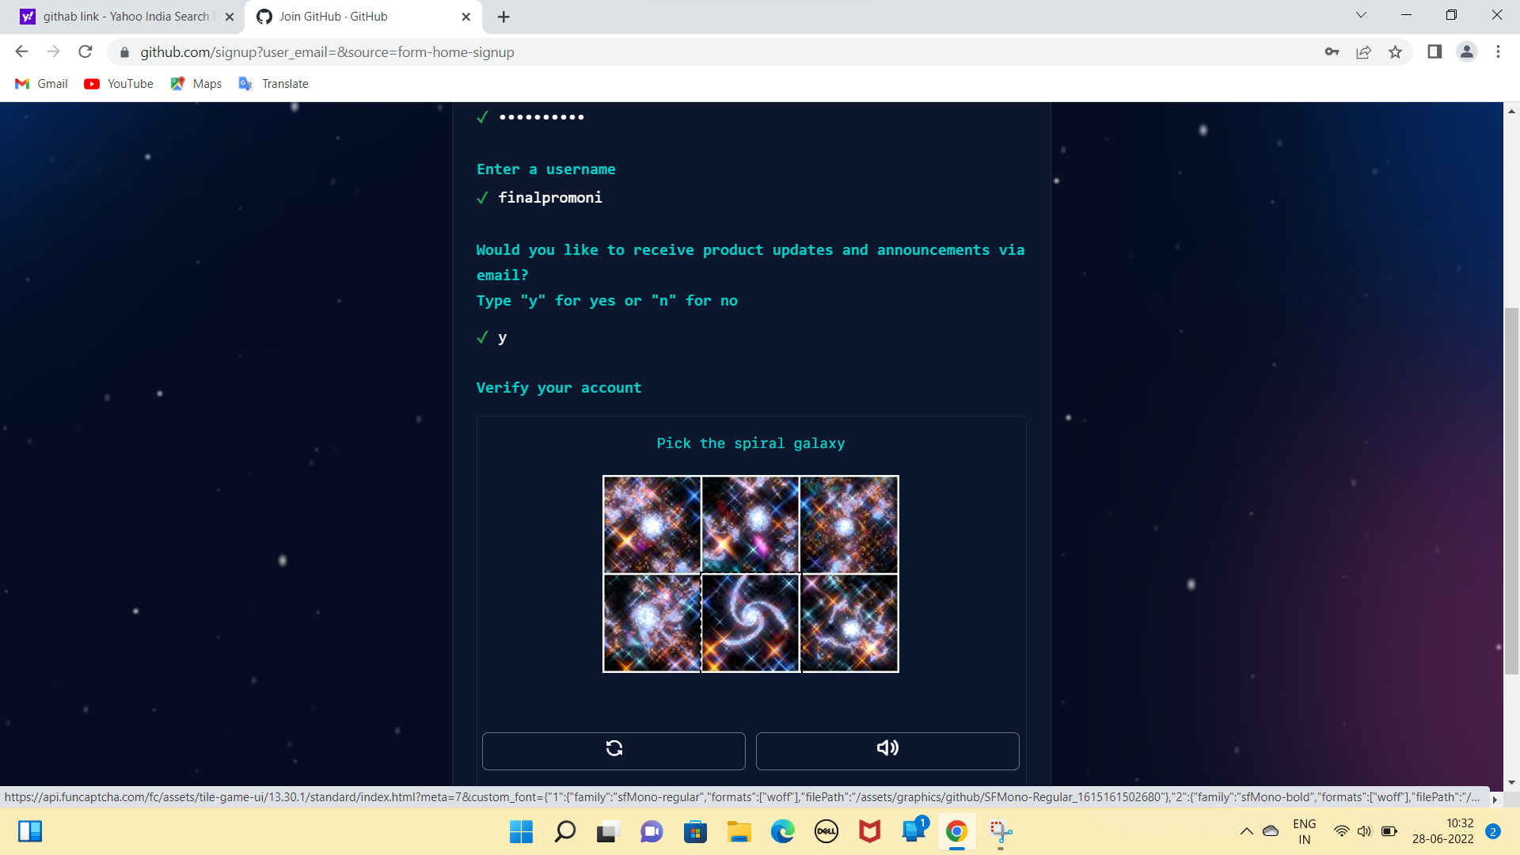

**Step4:-** now you will receive a 8 digit code to your email id..

* Copy that code and paste

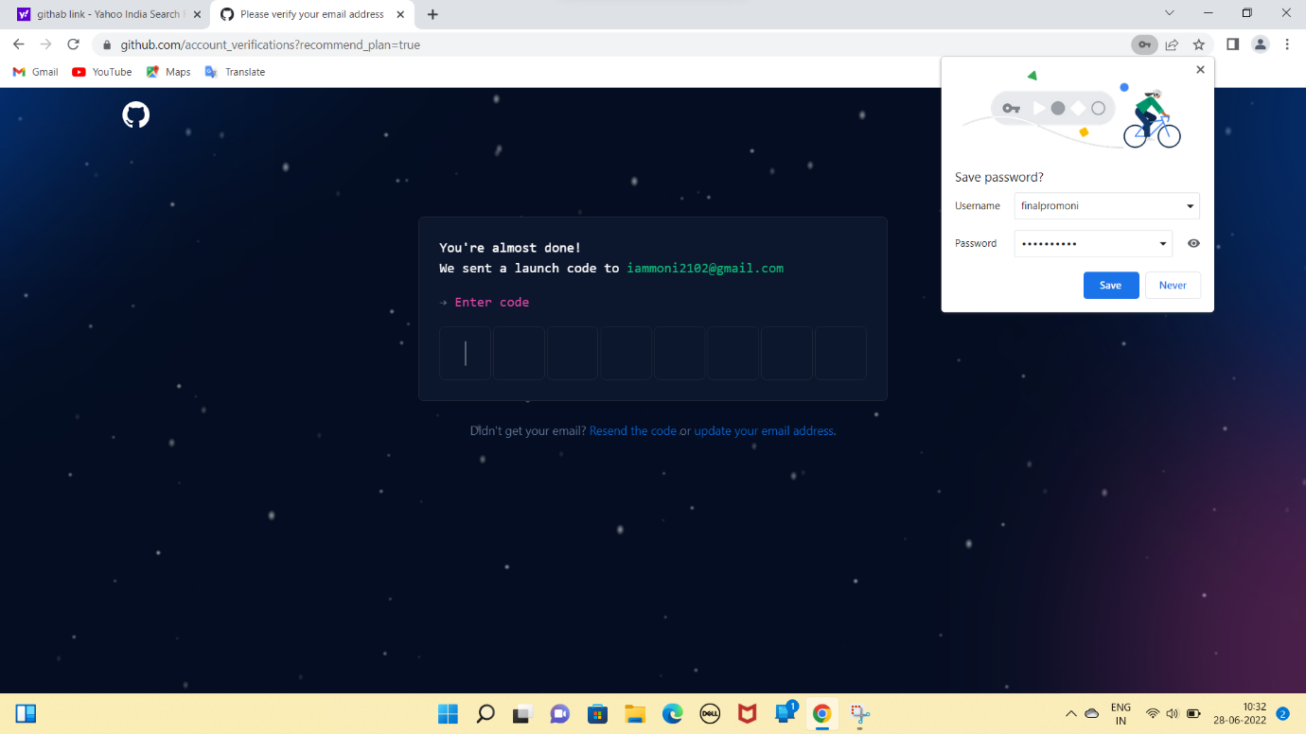

**Step5:-**

* now select the number of members in team
* select student if you are student
* press continue

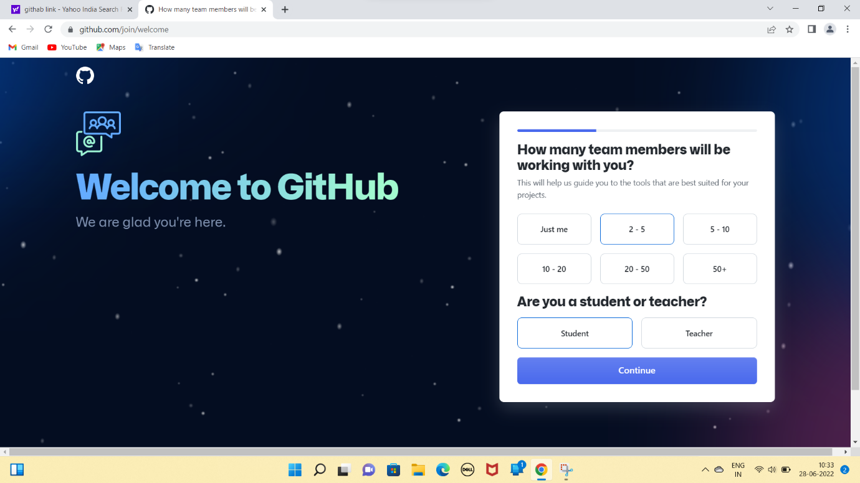

**Step6:-** after selecting the student option….click on continue for free

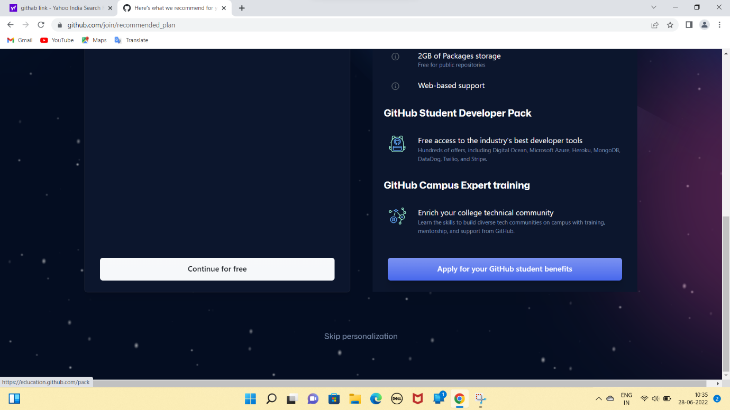

**Step7:-** now a actual github account page will appear..

* click on create a new repository

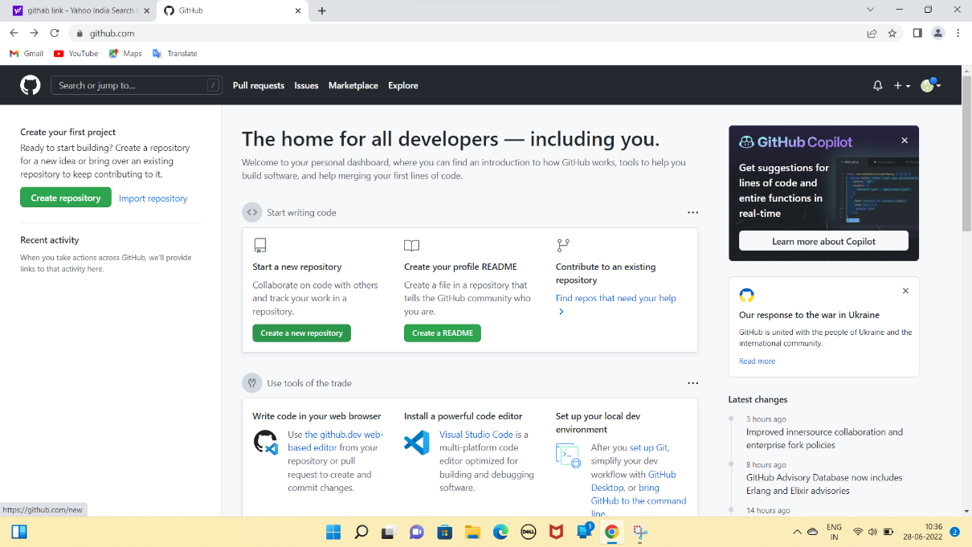

**Step8:-** enter your repository name and select the options according to your requirement and click create repository.

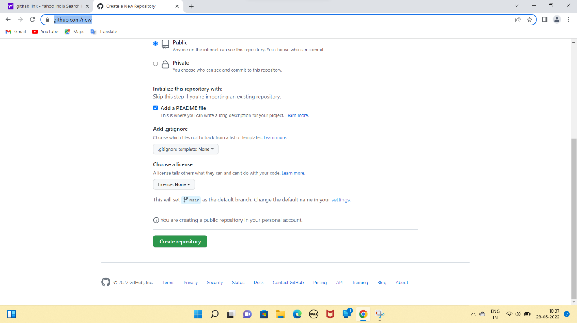

**Step9:-** now your project page will appear

* click on code
* copy the link and use as per your needs.

